**Re-operate Lake Powell and Lake Mead for Ecosystem and Water Supply Benefits**

## Moazzam Ali Rind and Mahmudur Rahman Aveek

## Utah State University

## 12 October 2020

## Abstract

The endemic fish population has been resurgent within the Grand Canyon reach of the Colorado River. While this population boom has been attributed to prolonged drought within the Colorado River basin, there are additional challenges those require further attention to sustain the native fish population, e.g., **ensuring temperature for spawning**, **sustaining bug population**, which is the primary food source, **hindering the encroachment of predatory fish** within the Grand Canyon region, etc. The purpose of this study is to create a hypothetical dam operation scenario to address these three issues mentioned above while ensuring that the Lower Basin states (California, Arizona, and Nevada) and Mexico get their yearly allotted water of 8.23 million acre-feet (MAF) fixed by the Colorado River Compact, 1922.

**Introduction**

The portion of Colorado river between Lake Powell and Lake Mead, known as the Grand Canyon (Figure 1), has a unique ecosystem, which has been home to number of endemic species for ages. For example, humpback chub (HBC), razorback sucker, bluehead sucker, flannel mouth sucker, and speckled dace are native fish species to Grand Canyon (National Park Service, 2014). The construction of Glen Canyon Dam (GCD) in 1963 has disturbed the natural physical and environmental processes of the Grand Canyon (Wright et. al., 2009, Schmidt et. al., 1998), which in turn has drastically affected the growth of native species. Some of the major impacts are the change in temperature which used to fluctuate greatly during pre-dam period to a relatively cold steady temperature, increased water clarity, reduced nutrient, changed flow pattern, reduced sediment load (Gloss et. al., 2005), hydropeaking, etc. But there has been a recent resurgence since the elevation at GCD has dropped during early 2000 due to drought condition; especially the Humpback chub (HBC) population has increased within the Grand Canyon reach, which was usually confined within the Little Colorado River, a tributary of the Colorado River (Rogowski et. al., 2018). The drought that started in early 2000, is somewhat responsible for this population boom, as the elevation of the Lake Powell decreased, the release temperature of the water increased which eventually has risen the river temperature within the Grand Canyon section of the river, and decrease in elevation of Lake Mead created the Pearce Ferry rapid at RM 281.5 which prevented non-native predatory species to swim upstream. While Colorado River Compact of 1922 and Water Treaty of 1944 ensures the Lower basin water requirement which are 7.5 and 1.5 maf/year (USBR) for Lower basin states and Mexico, the reduced river flow has proved to be of great importance for native fauna. The present study will try to create a hypothetical scenario to ensure,

* the water temperature is adequate (14-20oc) in summer months within the Grand Canyon Reach of the Colorado River which is a requirement for the spawning of native fish population.
* the elevation gap at Pearce Ferry Rapid is maintained to block the predatory fishes coming from Lake Mead.
* the lower basin states and Mexico will get the required amount of 8.23 MAF per year.

**Literature Review**

Most of the native fishes are acclimatized to temperature fluctuation (from 0°C to 27°C during pre-dam period), but spawning occurs during summer months when temperature exceeds a certain threshold (Gloss et. al., 2005). For instance, humpback chub, an endangered fish species, requires summer water temperatures in between 14 to 25 °C to spawn (Valdez et. al., 2013). Also, its greatest egg hatching success occurs at 20°C (U.S. Fish and Wildlife Service). Before the construction of Glen Canyon Dam, the water temperature within the Grand Canyon was highly variable; with icy spring run-off to the warm 29.4°C summer flows (Glen Canyon Dam Wiki, 2020). However, after the operation of Glen Canyon Dam, the river turned in to cold monotonous stream (Figure 2). As a result, the late-twentieth century studies found that the population of HBC was restricted to the Litter Colorado River and nearby areas in the mainstem Colorado River only (Glen Canyon Dam Wiki, 2020 and Rogowski et. al., 2018). However, recent surveys indicate a resurgence of the HBC population near the western region of the Grand Canyon. Researchers has determined that the western Grand Canyon HBC is relatively young and hypothesized that the resurgence happened after 2000 (Rogowski et. al., 2018). Specifically, there are speculations that Powell was at its lowest in 2005 and it was releasing warm water (15 °C) comparatively that would have helped the growth of the humpback Chub (Voichick et. al., 2007). Likewise, there are evidence showing the growth of other native fish populations such as Bluehead Sucker, Flannel mouth Sucker, and Speckled Dace in recent years (Kegerries et. al., 2020).

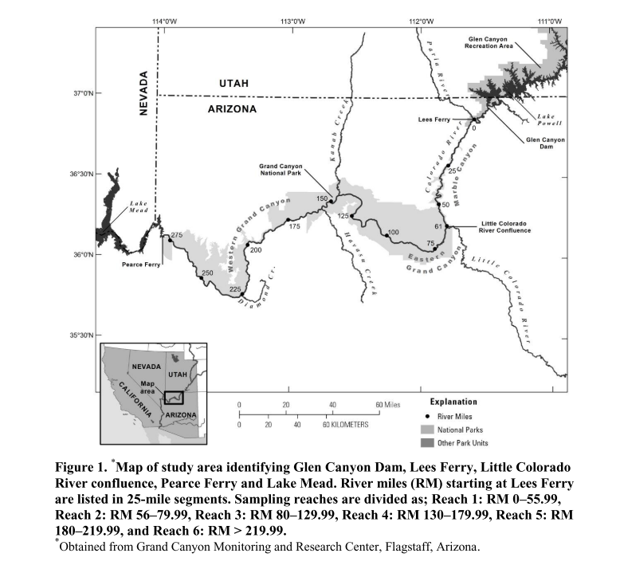

Figure 1: Different reaches of the Colorado River at Grand Canyon (Bunch et. al., 2012)

Besides stream temperature, there can be number of possible reasons attributed to this revival of native fish population in the Grand Canyon. For instance, creation of natural barrier called Pearce Ferry Rapid that obstruct the upstream movement of non-native fishes from Lake Mead, Trout management flows between 2003-05 that controlled the non-native trout fish population by destroying trout eggs (USGS 2011), and High Flow experiments (HFEs) which helped: rate of sediments transport, development of sand bars, removal of non-native vegetation, and growth rate of native flora and funa (Rice 2012). At present, to increase river food web in the Grand Canyon, bug flow experiments are in practice since summer 2018. The idea behind bug flow experiment is to provide steady low flows on weekend for invertebrates to lay and hatch eggs (Kennedy et. al., 2016). Since it is an on-going experiment, therefore, the eco-system benefits from the experiment are inconclusive, but hydropower benefits from the experiment are encouraging.

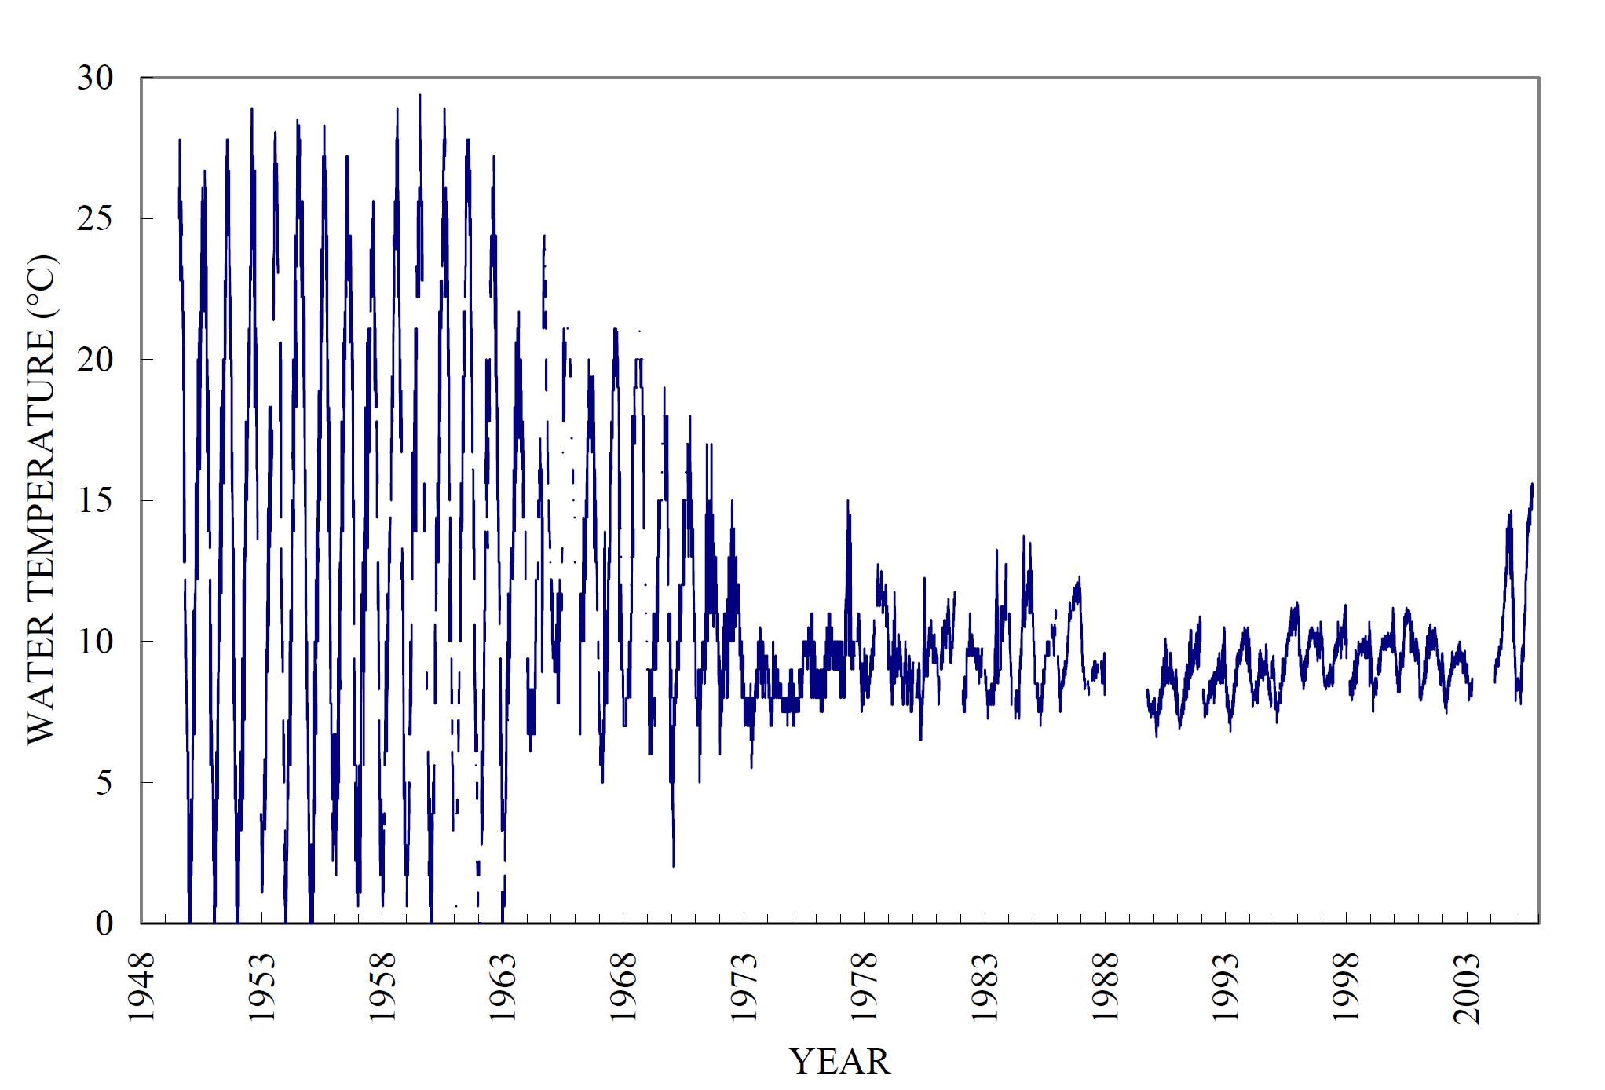

Figure 2 Daily water temperature measured or calculated at Lees Ferry gauge (station id 09380000) (Voichick et. al., 2007)

Geographically, the Colorado River passes through seven western states (i.e. Arizona, California, Colorado, Nevada, New Mexico, Utah, and Wyoming) of U.S and drains into the ocean in Mexico. The equitable allocation and distribution of Colorado River water among the stakeholders is ensured through Colorado River compact of 1922 (USBRa). The compact divided the states into two basins: Upper basin which consists of Colorado, Utah, Wyoming and New Mexico and Lower basin that includes Nevada, Arizona, and California. Although Mexico was recognized as shareholder of the Colorado River in the 1922 compact, but its share was not decided until Mexican water treaty of 1944 (USBRb). Article III of Colorado River compact,1922 allocates equal amount of share to both the basins i.e.7,500,000 acre-feet of water per annum. It also enforces that the upper basin states will not cause the flow of the river at Lee Ferry to be depleted below an aggregate of 75,000,000 acre-feet for any period of ten consecutive years. In addition, the Colorado River compact in various of its articles allows the development of storages facilities, water supply network, and hydropower generation plants to get maximum benefit from the apportioned water. For instance, Hoover Dam was built in lower basin in 1936 to control floods, ensure continuous water supply and produce hydropower. Likewise, Glen Canyon Dam was completed in 1966 and its main reason was to safeguard lower basin water share and produce hydropower. In 1922 compact, the share to Mexico will be upheld by any of basin in surplus or both basins will contribute equally.

This study is aimed to build a systems model for the Grand Canyon Reach of the Colorado River considering water supply, and eco-system objectives. The presented work will explore possible operational schemes for both reservoirs under different volumetric and ecological scenarios. The developed model will be helpful to quantify trade-off between ecosystem and Lower Basin water requirement objectives. Which means the model will give us a hydrograph for Glen Canyon Dam which will favor ecosystem objective (i.e. number of steady low flow days) which is required for the growth of the bug population, the primary food source of native fishes within the Grand Canyon Reach.

Kennedy et al., (2016) in their study found that dams with high intensity of hydropeaking -sub daily fluctuation in releases to meet energy demand—has low invertebrates’ diversity. Hence, providing large number of steady low flow days will help increase bugs population. Which in other words means more food available for fishes. Another recent study which is under review, attributed the rise in river temperature to GCD releases, especially within the first 141 kilometer from the GCD, for the rest of the region, the increase in temperature is attributed to a combination of discharge, short water radiation and local air temperature (Mihalevich et. al., 2020). So, the model will also try to incorporate the developed reservoir elevation and downstream temperature relationships for Lake Powell (e.g. Figure 3) in order to provide favorable conditions for native fishes. Finally, the hydrograph for Hoover Dam help us meet the lower basin demands and keep the Lake Mead Elevation lower than 1135 ft. While increased temperature is a requirement for the native fishes during the summer months, it will also favor the non-native fishes such as channel catfish, common carp, fathead minnows [National Park Service, 2018]. It is uncertain how raising the temperature will affect the native and non-native ecosystem, but to reduce further complexity, this study will to delve into the ecology part of the Grand Canyon reach, and consider that a temperature range between 14-20oc will only benefit the endemic fish population.

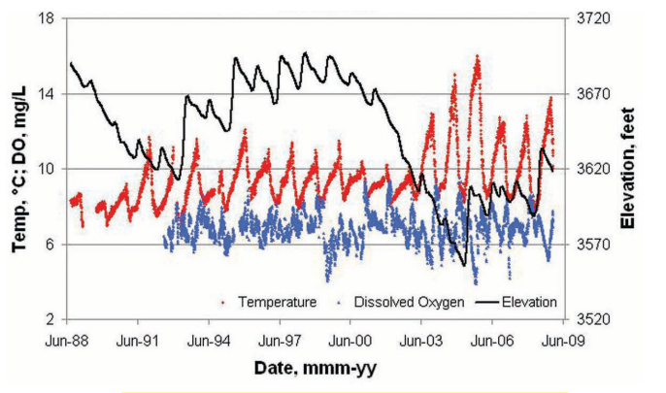

Figure 3 Daily water temperature and dissolved oxygen concentration below Glen Canyon Dam with Lake Powell water- surface elevations, 1988–2008 (Williams, 2009)

**Model Description**

This is a monthly timestep model which run for a period of three years. It calculates the average monthly flows (cfs) required to maintain the storage of the reservoirs at desired level. The aim here is to encourage release scheme having maximum number of stable flows for the Grand Canyon and keep the reservoir storages at levels which produce releases of desired temperatures. As mentioned earlier, this a multi-objective study ….. (Appendix-2)

**Model Formulation**

*Decision variables*: Storage in Glen Canyon Dam (ac-ft), Storage in Hoover Dam (ac-ft), Release hydrograph from Glen Canyon Dam (cfs/day), Release hydrograph from Hoover Dam (cfs/day).

*Objective function (s):* Maximize the number of steady flow days to support invertebrates growth and number of months Glen Canyon Dam has storage levels favorable to get required release temperatures for native fish populations of the Grand Canyon.

Constraints:

A schematic is for the study is provided in Appendix 1. The constraint equations are provided below.

1. Elevation at Lake Mead <=1135 ft​.

This is the elevation of Pearce Ferry Rapid that keeps warm-water non-native fish from swimming upstream into Grand Canyon.

1. Lower basin water demand [0.6-1.2 maf/ month]​ (Glen Canyon Dam Wikib, 2020)

Depending upon the month of the year and available storage in reservoirs, the lower basin supply varies.

1. Structural Constraint [capacity of the Dam (ac-ft), capacity of the turbines (cfs), Lowest elevation/ reservoir storage required for Hydropower (ac-ft)] at Glen Canyon Dam​
2. Operational Constraints at GC Dam [ release >= 8000 cfs daily] ​ (U.S. Department of the Interior. (2016))

This constraint is suggested in LTEMP Record of Decision (2016) to ensure sediment conservation benefits as well as recreation and safety benefits.

1. Structural Constraint [capacity of the Dam (ac-ft), capacity of the turbines (cfs), Lowest elevation/ reservoir storage required for Hydropower (ac-ft)] at Hoover Dam​
2. Operational Constraints at Hoover Dam [outflow from Hoover Dam (cfs)]​
3. Suitable stream temperatures required at the following RM points for native fishes in the Grand Canyon [equations relating downstream stream temperatures at different locations in the Grand Canyon with storage of the Glen Canyon Dam]​
4. Implementation of equalization policy [same amount of storage in both reservoirs (ac-ft)].
5. Mass balance at both the reservoirs and some of the locations within the Grand Canyon.

*Parameters:*

1. Inflow to the Glen Canyon dam (ac-ft /month)

2. Evaporation from both the reservoirs (ac-ft/month)

3. Initial storage in both the reservoirs (ac-ft/month)

4. Upper and lower release limits for both the reservoirs (cfs).

5. Total annual release volume from Glen Canyon Dam and from Hoover Dam

6. Minimum and maximum storage capacities of the reservoirs (ac-ft)

7. Required river temperature at different locations in the Grand Canyon (Oc)

8. Number of steady flow days factors. Different factor values represent number of steady flow days scenarios per month.

Variables:

1. Storage level in both the reservoirs (ac-ft)

2. Releases from both the reservoirs (cfs)

Primary Result

Future Challenges

**References:**

Bunch, A. J., Osterhoudt, R. J., Anderson, M. C., & Stewart, W. T. (2012). *Colorado River Fish Monitoring in Grand Canyon , Arizona — 2012 Annual Report*. (December), 1–41. <https://doi.org/10.13140/RG.2.2.31954.61124>

Glen Canyon Dam Wikia, (2020), <https://gcdamp.com/index.php?title=TEMPERATURE>

Glen Canyon Dam Wikib, (2020), <http://gcdamp.com/index.php?title=File:LTEMP_monthly_volumes.png>

Gloss, S., Lovich, J., & Melis, T. (2005). *The State of the Colorado River Ecosystem in Grand Canyon: USGS Circular 1282*.

Kegerries, R. B., Albrecht, B., McKinstry, M. C., Rogers, R. J., Valdez, R. A., Barkalow, A. L., … Smith, E. O. (2020). Small-Bodied Fish Surveys Demonstrate Native Fish Dominance Over 300 Kilometers of the Colorado River Through Grand Canyon, Arizona. Western North American Naturalist, 80(2), 146. <https://doi.org/10.3398/064.080.0202>

Kennedy, T. A., Muehlbauer, J. D., Yackulic, C. B., Lytle, D. A., Miller, S. W., Dibble, K. L., & Baxter, C. V. (2016). Flow management for hydropower extirpates aquatic insects, undermining river food webs. BioScience, 66(7), 561-575.

Mihalevich, B. A., Neilson, B. T., Buahin, C. A., Yackulic, C., & John, C. (n.d.). *Water temperature controls for regulated rivers in complex topographic regions*.

National Park Service (July 24, 2018), (<https://www.nps.gov/grca/learn/nature/fish-native.htm>)

Rice, J. Controlled Flooding in the Grand Canyon: Drifting Between Instrumental and Ecological Rationality in Water Management. Organization & Environment, 26(4), 412–430. https://doi.org/10.1177/1086026613509250 (2013).

Rogowski, D. L., Osterhoudt, R. J., Mohn, H. E., & Boyer, J. K. (2018). Humpback Chub (Gila cypha) Range Expansion in the Western Grand Canyon. Western North American Naturalist, 78(1), 26–38. <https://doi.org/10.3398/064.078.0105>

Schmidt JC, Webb RH, Valdez RA, Marzolf GR, Stevens LE. 1998. Science and values in river restoration in the Grand Canyon. BioScience 48:735–747.

United States Bureau of Reclamation <https://www.usbr.gov/lc/region/pao/pdfiles/crcompct.pdf>

United States Bureau of Reclamation <https://www.usbr.gov/lc/phoenix/AZ100/1940/mexican_water_treaty.html#:~:text=The%20Mexican%20Water%20Treaty%20of,Colorado%20River%20Compact%20of%201922>

U.S. Department of the Interior. (2016). *Record of decision for the Glen Canyon Dam long-term experimental and management plan final environmental impact statement*. 196.

U.S. Fish and Wildlife Service (<https://www.fws.gov/fisheries/freshwater-fish-of-america/humpback_chub.html#:~:text=The%20humpback%20chub%20reaches%20sexual,57.2%20%E2%80%90%2075.2%20degrees%20Fahrenheit>.)

U.S. Geological survey. <https://pubs.usgs.gov/fs/2011/3002/fs2011-3002.pdf>

Valdez, R. A., Speas, D. W., & Kubly, D. M. (2013). Benefits and risks of temperature modification at Glen Canyon Dam to aquatic resources of the Colorado River in the Grand Canyon. U.S. Bureau of Reclamation, Upper Colorado Region, Salt Lake City, UT, (September).

Voichick, N., & Wright, S. A. (2007). Water-temperature data for the Colorado River and tributaries between Glen Canyon Dam and Spencer Canyon, northern Arizona, 1988-2005 (p. 24). Washington, DC: US Geological Survey.

Williams, N. T. (2009). Projecting Temperature in Lake Powell and the Glen Canyon Dam Tailrace. 2008, 1–9. Retrieved from <https://www.researchgate.net/profile/Theodore_Melis/publication/258998603_Proceedings_of_the_Colorado_River_Basin_Science_and_Resource_Management_Symposium_November_1820_2008_Scottsdale_Arizona/links/00b7d529a09f5a86cb000000.pdf#page=165>

Wright, S. A., Anderson, C. R., & Voichick, N. (2009). A simplified water temperature model for the Colorado River below Glen Canyon Dam. *River Research and Applications*, *25*(6), 675–686. [https://doi.org/10.1002/rra.1179](https://doi.org/10.1002/rra.1179\)

Appendix 1

Figures

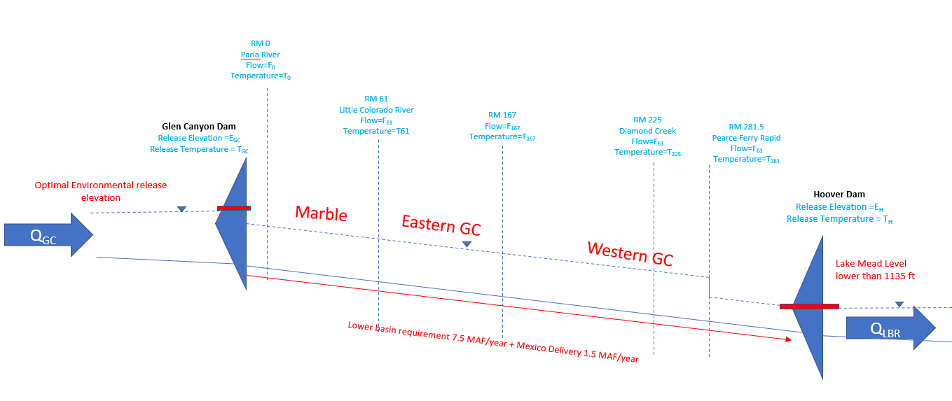

Figure A1: Schematic of the problem

Appendix 2

**Model Formulation**

|  |  |
| --- | --- |
| **Sets** | |
| M | Months in 3 successive year: M1*M36 |
| P | Periods in a day: pLow and pHigh [off peak and on peak respectively] |
| modpar | Saving model parameter: ModStat and SolStat [Model and Solve Statistics respectively] |
| case | The four sub-objectives: case1*case4 |
| powell_rule | Five Rules to release water from Lake Powell: powell_rule1*powell_rule5 |
| mead_rule | Two rules to release water form Lake Mead: mead_rule1*mead_rule2 |
| **Data** | |
| Inflow_Powell | Inflow coming to Powell for UB states per month [maf] for WY2017-2020 |
| Inflow_Paria | Inflows from Paria River to the Colorado River near Glen Canyon per month [maf] for WY2017-2020 |
| Inflow_LitColorado | Inflows from Little Colorado River to the Colorado River near Glen Canyon per month [maf] for WY2017-2020 |
| Inflow_KanabCreek | Inflows from Kanab Creek to the Colorado River near Glen Canyon per month [maf] for WY2017-2020 |
| Inflow_Havasu | Inflows from Havasu Creek to the Colorado River near Glen Canyon per month [maf] for WY2017-2020 |
| Inflow_Diamond | Inflows from Diamond Creek to the Colorado River near Glen Canyon per month [maf] for WY2017-2020 |
| evap_Mead | Lake Mead monthly Evaporation [maf] for WY2017-2020 |
| evap_Powell | Lake Powell monthly Evaporation [maf] for WY2017-2020 |
| Init_Powell | 14664000 acf |
| Init_Mead | 10182000 acf |
| **Decision Variables** | |
| **Mass balance at different locations** | |
| Storage_Powell(M) | Storage in Lake Powell at each time step (acf) |
| Flow_atParia(M) | Inflows at the confluence point of Paria River (acf) |
| Flow_atlitColorado(M) | Inflows at the confluence point of Little colorado River (acf) |
| Flow_atDiamond(M) | Inflows at the confluence point of Dimaond creek (acf) |
| Storage_Mead(M) | Storage in Lake Mead at each time step (acf) |
| LB_Delivery(M) | Outflow_Powell(M) + Inflow_Paria (M) |
| EOM_Powell(M) | End of the month storage at Lake Powell (acf) |
| EOM_Mead(M) | End of the month storage at Lake Mead (acf) |
| **Volumes** | |
| Vol_Powell | Total volume of water released from lake powell during study period (ac-ft) |
| Vol_Mead | Total volume of water released from lake Mead during study period (ac-ft) |
|  |  |
| **Constraints** | |
| **Mass Balance** | |
| EQ1_BalancePowell(M) | **Mass Balance at Lake Powell** [acf]  For month 1,  Storage_Powell (M1) = Init_Powell (“Powell Initial Storage”)+ Inflow(M1) – evav_Powell(M1) – Outflow_Powell(M1) *Convert  For rest of the months (2nd to 36th month),  Storage_Powell(M2:M36) = Storage_Powell (M1:35) + Inflow(M2:M36) – evav_Powell(M2:M36) – Outflow_Powell (M2:M36)*Convert  The outflow will be controlled by a set of rules for lake Powell  The convert constant converts cfs value to acf |
| EQ2_BalanceParia(M) | **Mass balance at Paria River conflunce** (acf)  Flow_atParia(M) = Outflow_Powell(M) + Inflow_Paria(M) |
| EQ3_BalanceLitColorado(M) | **Mass balance at Little Colorado river conflunce** (acf)  Flow_atlitColorado(M) = Flow_atParia(M) + Inflow_LitColorado(M) |
| EQ4_BalanceDiamond(M) | **Mass balance at Diamond creek confluence** (acf)  Flow_atDiamond(M) = Flow_atlitColorado(M) + Inflow_Havasu (M) + Inflow_Diamond(M) + Inflow_KanabCreek (M) |
| EQ5_BalanceMead(M) | **Mass Balance at Lake Mead** (maf)  For month 1,  Storage_Mead (M1) = Init_Mead (“Mead Initial Storage”)+ Flow_atDiamond(M1) – evap_Mead (M1) – Outflow_Mead(M1)*Convert  For rest of the months (2nd to 36th month),  Storage_Mead(M2:M36) = Storage_Mead (M1) + Inflow (M2:M36)– evap_Mead (M2:M36) – Outflow_Mead (M2:M36)*Convert  The outflow will be controlled by a set of rules for lake Mead  The convert constant converts cfs value to acf |
| **Releases[cfs]** | |
| Max_RelMead | 49000 cfs |
| Min_RelMead | 8000 cfs |
| Max_RelPowell | 31500 cfs |
| Min_RelPowell | 8000 cfs |
| **Storage [acf]** | |
| Maxstorage_Mead | 27767000 [acf] |
| Minstorage_Mead | 7683000 [acf] |
| Maxstorage_Powell | 27865918 [acf] |
| Minstorage_Powell | 5892163 [acf] |
|  |  |

**Release Rules from Lake Powell for Month 1 to Month 36**

|  |  |  |  |
| --- | --- | --- | --- |
| **Month** | **Month number** | **Outflow_Powell** | **Rule Type** |
| October | 1 | monthly release beteen 0.6 to 1.2 maf (8000 cfs <=Release(CFS) <= 31500 cfs) | 1 |
| November | 2 | monthly release beteen 0.6 to 1.2 maf (8000 cfs <=Release(CFS) <= 31500 cfs) | 1 |
| December | 3 | monthly release beteen 0.6 to 1.2 maf (8000 cfs <=Release(CFS) <= 31500 cfs) | 1 |
| January | 4 | monthly release beteen 0.6 to 1.2 maf (8000 cfs <=Release(CFS) <= 31500 cfs) | 1 |
| February | 5 | monthly release beteen 0.6 to 1.2 maf (8000 cfs <=Release(CFS) <= 31500 cfs) | 1 |
| March | 6 | monthly release beteen 0.6 to 1.2 maf (8000 cfs <=Release(CFS) <= 31500 cfs) | 1 |
| April | 7 | Maximum release to bring down WL to 3530, e.g., storage must come down to 6.27 MAF (Release = 31500 cfs) | 2 |
| May | 8 | Controlled Release to maintain elevation at lake Powell between 3530 ft and 3490 ft (8000 cfs <=Release(CFS) <= 31500 cfs) | 3 |
| June | 9 | Controlled Release to maintain elevation at lake Powell between 3530 ft and 3490 ft (8000 cfs <=Release(CFS) <= 31500 cfs) | 3 |
| July | 10 | Controlled Release to maintain elevation at lake Powell between 3530 ft and 3490 ft (8000 cfs <=Release(CFS) <= 31500 cfs) | 3 |
| August | 11 | Controlled Release to maintain elevation at lake Powell between 3530 ft and 3490 ft (8000 cfs <=Release(CFS) <= 31500 cfs) | 3 |
| September | 12 | minimum release | 4 |
| October | 13 | minimum release | 4 |
| November | 14 | minimum release | 4 |
| December | 15 | minimum release | 4 |
| January | 16 | minimum release | 4 |
| February | 17 | minimum release | 4 |
| March | 18 | minimum release | 4 |
| April | 19 | if storage> 6.27MAF, Maximum release to bring down WL to 3530, e.g., storage must come down to 6.27 MAF (Release = 31500 cfs), else (if 4.096MAF<Storage<6.27MAF, Controlled Release), else(Minimum release) | 5 |
| May | 20 | Controlled Release to maintain elevation at lake Powell between 3530 ft and 3490 ft (8000 cfs <=Release(CFS) <= 31500 cfs) | 3 |
| June | 21 | Controlled Release to maintain elevation at lake Powell between 3530 ft and 3490 ft (8000 cfs <=Release(CFS) <= 31500 cfs) | 3 |
| July | 22 | Controlled Release to maintain elevation at lake Powell between 3530 ft and 3490 ft (8000 cfs <=Release(CFS) <= 31500 cfs) | 3 |
| August | 23 | Controlled Release to maintain elevation at lake Powell between 3530 ft and 3490 ft (8000 cfs <=Release(CFS) <= 31500 cfs) | 3 |
| September | 24 | minimum release | 4 |
| October | 25 | minimum release | 4 |
| November | 26 | minimum release | 4 |
| December | 27 | minimum release | 4 |
| January | 28 | minimum release | 4 |
| February | 29 | minimum release | 4 |
| March | 30 | minimum release | 4 |
| April | 31 | if storage> 6.27MAF, Maximum release to bring down WL to 3530, e.g., storage must come down to 6.27 MAF (Release = 31500 cfs), else (if 4.096MAF<Storage<6.27MAF, Controlled Release), else(Minimum release) | 5 |
| May | 32 | Controlled Release to maintain elevation at lake Powell between 3530 ft and 3490 ft (8000 cfs <=Release(CFS) <= 31500 cfs) | 3 |
| June | 33 | Controlled Release to maintain elevation at lake Powell between 3530 ft and 3490 ft (8000 cfs <=Release(CFS) <= 31500 cfs) | 3 |
| July | 34 | Controlled Release to maintain elevation at lake Powell between 3530 ft and 3490 ft (8000 cfs <=Release(CFS) <= 31500 cfs) | 3 |
| August | 35 | Controlled Release to maintain elevation at lake Powell between 3530 ft and 3490 ft (8000 cfs <=Release(CFS) <= 31500 cfs) | 3 |
| September | 36 | minimum release | 4 |

**Release Rule from Mead**

|  |  |  |
| --- | --- | --- |
| **Month number** | **Outflow_Mead** | **Rule_Type** |
| M1:M36 | If elevation > 1135, e.g., storage > 15.12 MAF,  Then maximum release of 49000 cfs | 1 |
| M1:M36 | If elevation < 1135, e.g., storage < 15.12 MAF,  Then 8000< mead release <49000 | 2 |

**Objective Function**

**Objective 1: Environmental flow**

We need to release water from an elevation higher than 3492 ft from Glen Canyon dam. The storage capacity at 3492 ft is 4.096 MAF (Source CRSS).

The flow for fishes is considered adequate (temperature wise) if the release is between 3530 ft and 3490 ft elevation e.g., 4.096 MAF and 6.27 MAF, respectively during May to August.

Obj_1 = $\sum_{M=1}^{M=36}{EOM_Powell is between 4.096 MAF 6.27 MAF}$

Obj_Fraction_1 = Obj_1 / 12 (M8:M11, M20:M23, M32:35)

**Objective 2: Lower basing demand**

Obj_Fraction_2 = $\frac{\sum_{M=1}^{M=36}{Number of years when delivery to LB is greater than 8.23 (LB_Delivery)}}{3}$

**Objective 3: Months when Mead elevation is less than 1135 ft**

The third objective is to keep the elevation at lake mead below 1135 ft above MSL. At 1135 ft, storage capacity of Lake Mead is 15.12 MAF.

Obj_Fraction_3 = $\frac{\sum_{M=1}^{M=36}{EOM_Mead < 15.12 MAF (@elevation 1135 ft)}}{36}$

**Combining the three objectives:**

**Max z = Obj_Fraction_1+ Obj_Fraction_2+ Obj_Fraction_3**